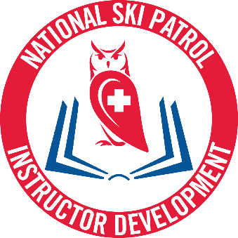

The Central New York Region is holding an ID Hybrid Course on Thursday, April 11th at 6:00 pm in the Mini Lodge at Labrador Mtn. We’ll provide a light supper for your travel and time. Pizza, salad & water. Your ‘to do list’ includes:
-Completing the Instructional Development: Student Hybrid Online portion BEFORE attending this in-person session. After completing the online portion, you will earn a certificate. That certificate must be either scanned and sent to me or brought with you to the in-person session on the 11th. If you do not do either, you won’t be able to complete the in-person session.
-Registering for the Instructional Development Hybrid Skills Session.
-Creating a lesson to deliver to 3-5 people where you introduce your objective, demonstrate it, observe your learners completing it and providing an overall assessment. (Your lesson needs to be simple enough to deliver in its entirety in 15 minutes. Please have enough supplies for 3-5 people in your lesson)
-Completing a 6 pack lesson plan for your lesson which must be completed before lesson delivery.
Please reach out to me with any questions, concerns and/or confusion.

